**LIT TRAINING**

**Batch Name : SAP ABAP ON HANA** **DAY11 ASSIGNMENT**

**EMPLOYEE ID – 46255244** **DATE : 13th September, 2022**

Exercise 1 – Creation of Smartform

Structure and Table Type for table of main window

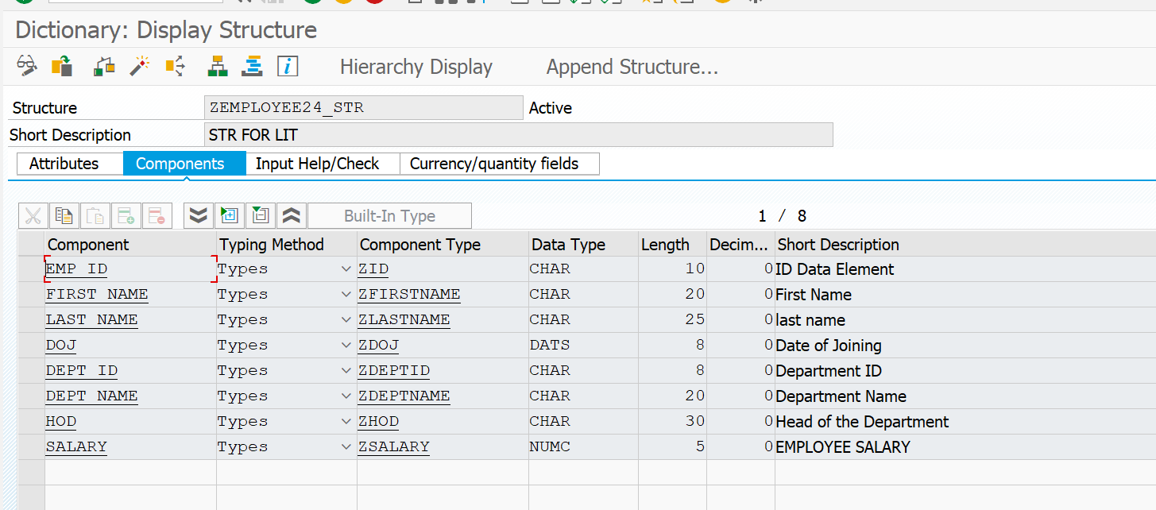

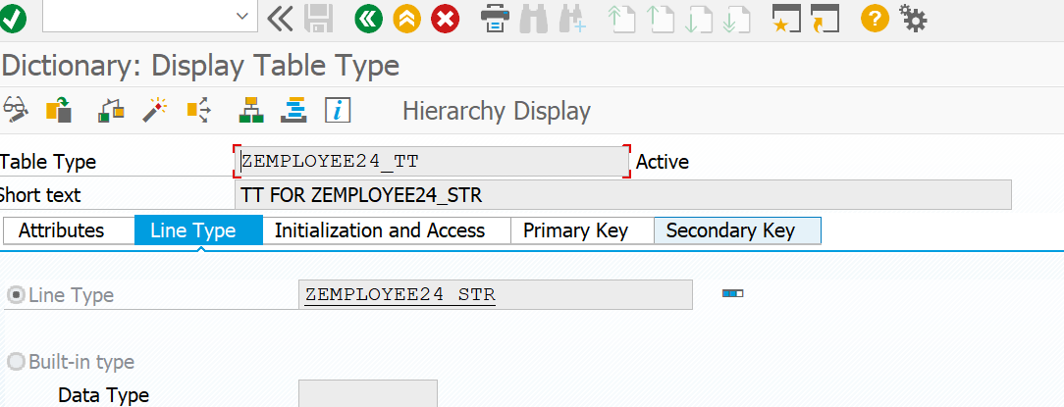

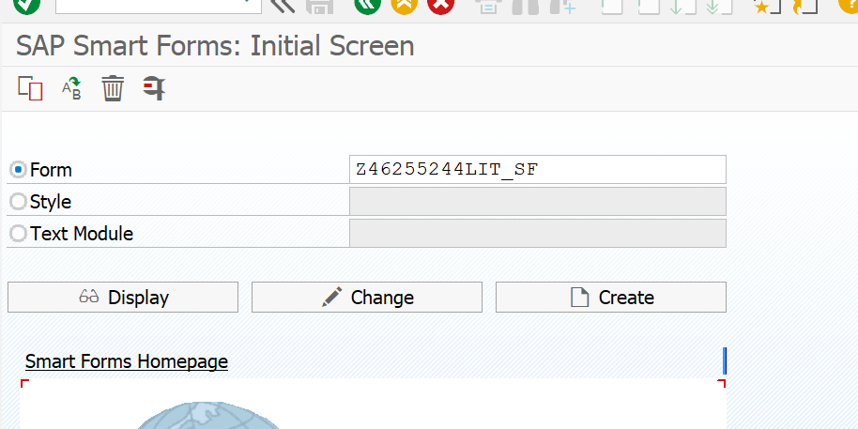

**Windows with given requirements**

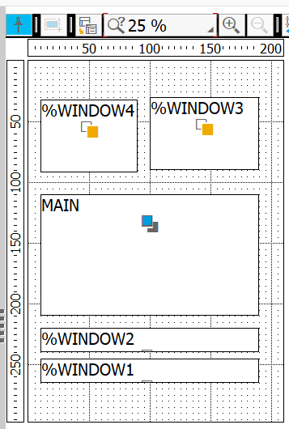

**Table definition**

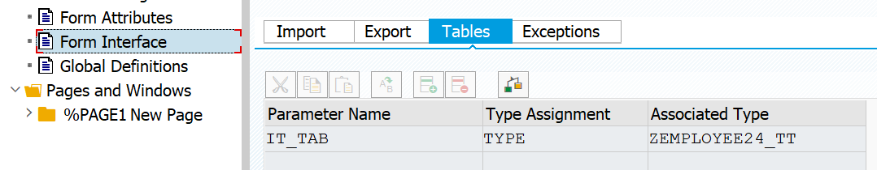

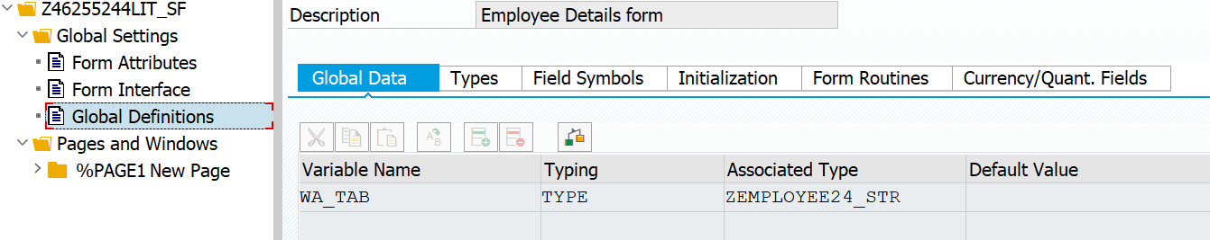

**Graphics to insert logo**

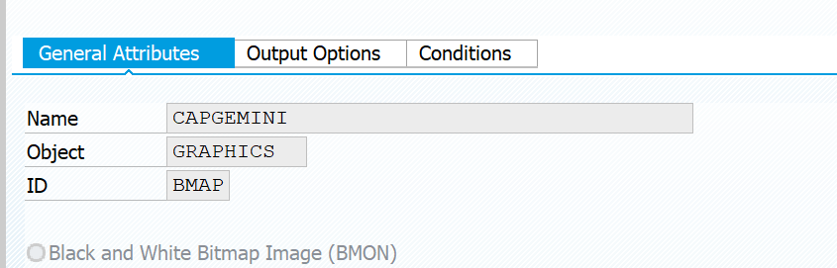

**Text to insert date**

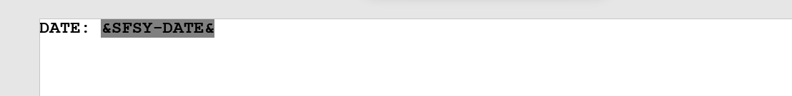

**Table**

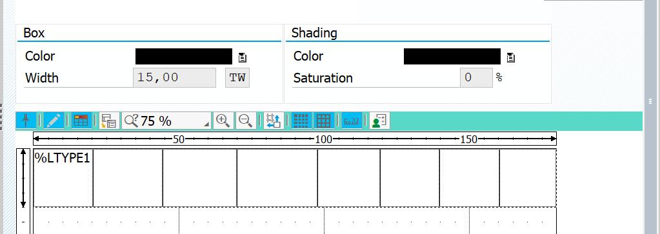

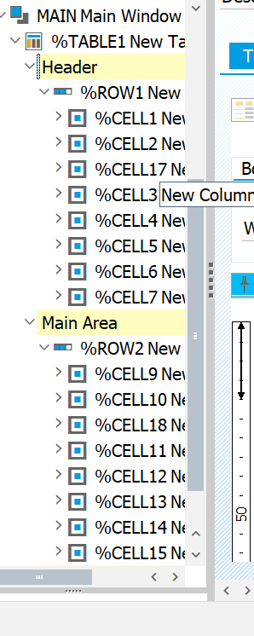

**CREATION OF TEXT STYLES**



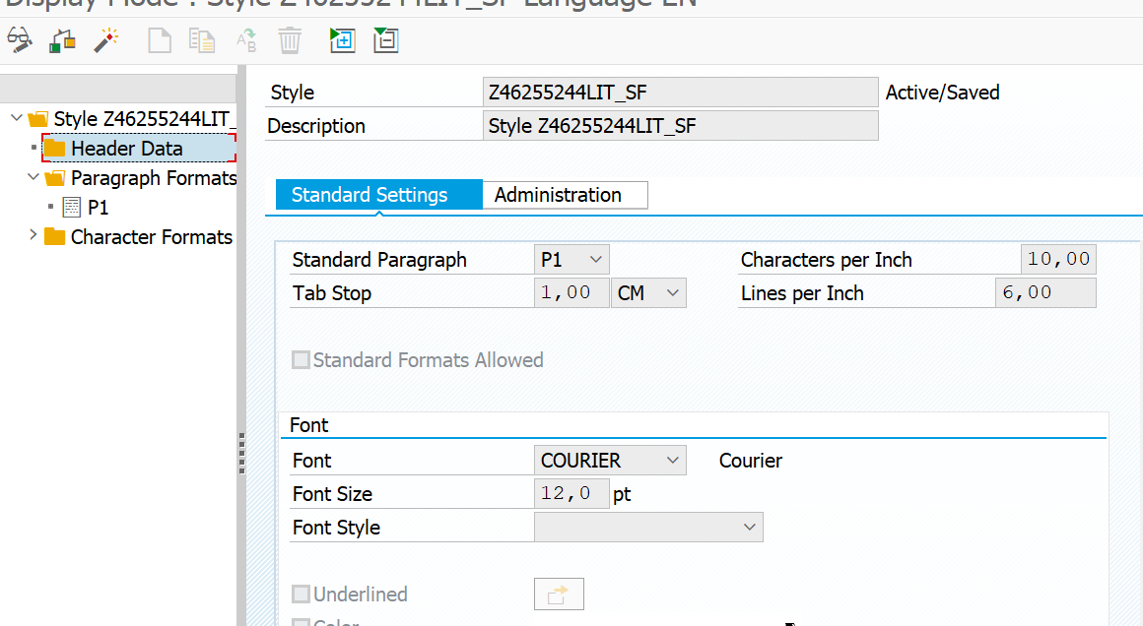

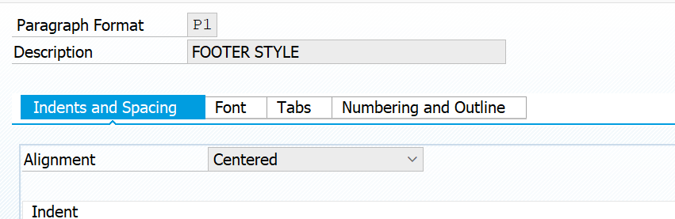

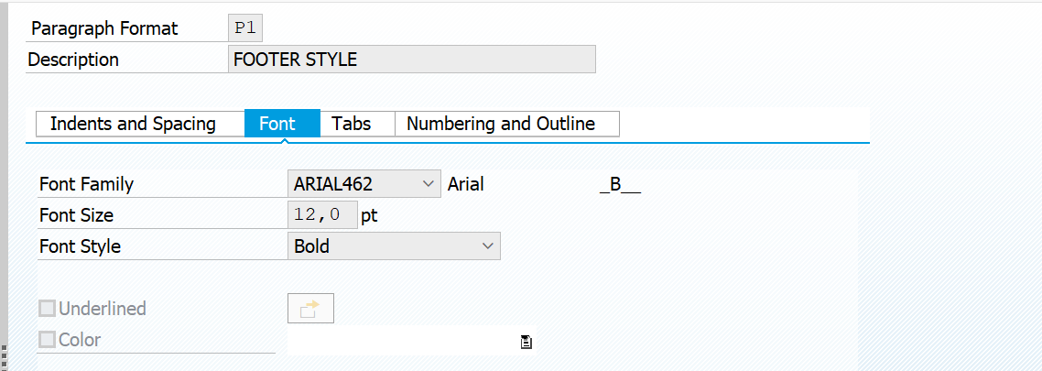

**OUTPUT:**

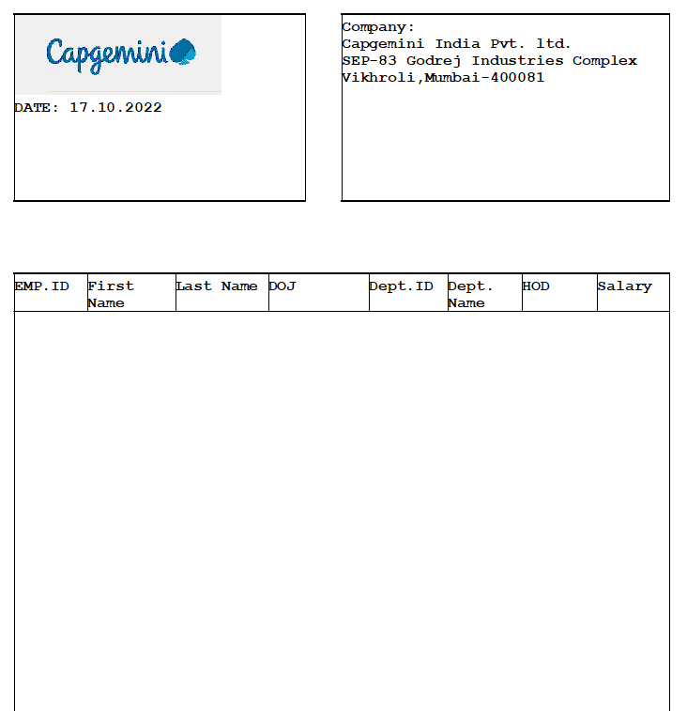

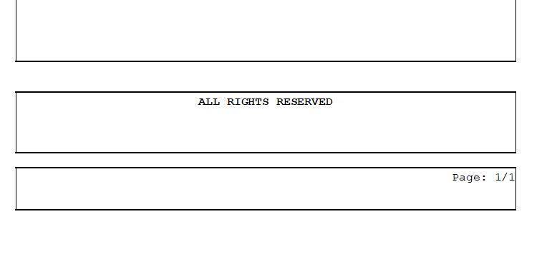

**DRIVER PROGRAM**

REPORT z46255244lit_sf.  
  
*TABLES:zemployee_24.  
  
DATA:fm_name TYPE rs38l_fnam,  
     it_tab  TYPE zemployee24_TT,  
     WA_tab  TYPE zemployee24_STR.  
  
SELECT EMP_ID  
FIRST_NAME  
LAST_NAME  
DOJ  
DEPT_ID  
DEPT_NAME  
HOD  
SALARY FROM ZEMPLOYEE_24 INTO TABLE IT_TAB.  
  
  
CALL FUNCTION '/1BCDWB/SF00000743'  
* EXPORTING  
*   ARCHIVE_INDEX              =  
*   ARCHIVE_INDEX_TAB          =  
*   ARCHIVE_PARAMETERS         =  
*   CONTROL_PARAMETERS         =  
*   MAIL_APPL_OBJ              =  
*   MAIL_RECIPIENT             =  
*   MAIL_SENDER                =  
*   OUTPUT_OPTIONS             =  
*   USER_SETTINGS              = 'X'  
* IMPORTING  
*   DOCUMENT_OUTPUT_INFO       =  
*   JOB_OUTPUT_INFO            =  
*   JOB_OUTPUT_OPTIONS         =  
  TABLES  
    it_tab                     = IT_TAB  
* EXCEPTIONS  
*   FORMATTING_ERROR           = 1  
*   INTERNAL_ERROR             = 2  
*   SEND_ERROR                 = 3  
*   USER_CANCELED              = 4  
*   OTHERS                     = 5  
          .  
IF sy-subrc <> 0.  
* Implement suitable error handling here  
ENDIF.

